FACULTY EVALUATION
Programme Name: Social Entrepreneurship Program (SEP) – SCALE MASTERCLASS Module 2 (ONLINE)– Uganda (1st June 2026 - 5th June 2026)
Session: Long-term sustainability planning
Faculty Name: Dr. Chilumba K. Bwalya
No. of Respondents: 6
No. of Participants: 10
Evaluation Parameter | (%) Individual Score | (%) Programme Average
Punctuality (Commencement and Completion of Sessions) | 88 | 83
How well do you understand the core concepts presented? | 92 | 90
Rate your confidence in applying the new skills learnt | 80 | 83
Degree of Faculty preparedness for the sessions | 92 | 94
Content and methodology of the program | 92 | 93
Quality of class and group discussions | 92 | 90
The information presented in the course is relevant to my work (ministry) | 92 | 94
Average scores | 90 | 90

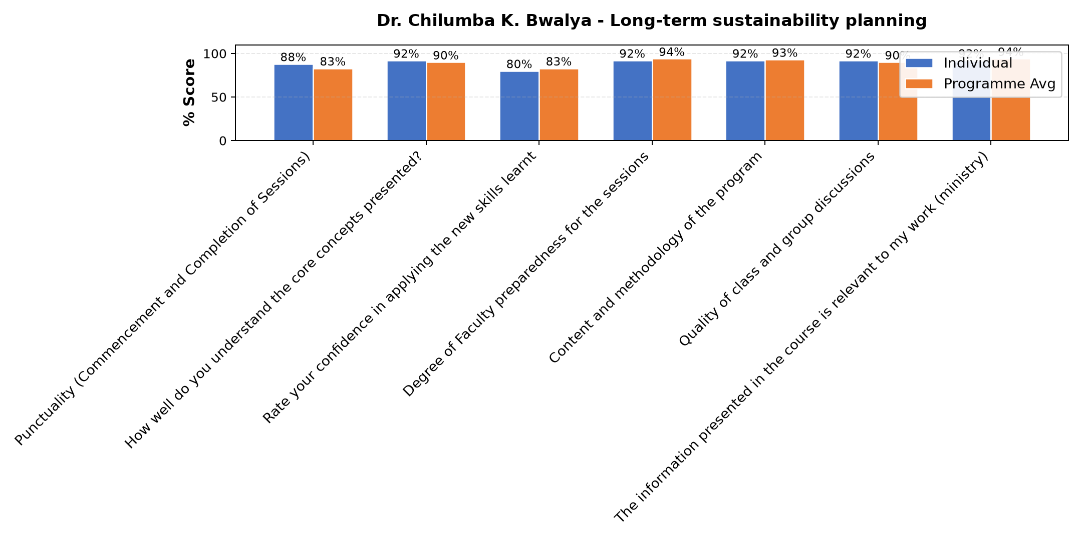

Comments & Feedback
- • My confidence
- • If am not informed
SUBMITTED THROUGH:
SBS Evaluation Automation System

